% Driver for Q1
close all
clear all
clc
a = 0;
b = 200;
h = 0.01;
x0 = 5;
y0 = 5;
z0 = 10;
[x,y,z] = RK4('lorentz',a,b,h,x0,y0,z0);
Equilibrium point:
7.302967393526780 7.302967675198756 19.999999541614901
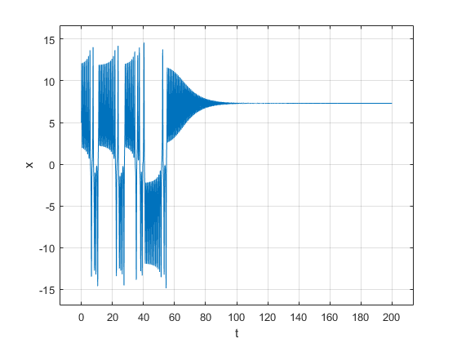
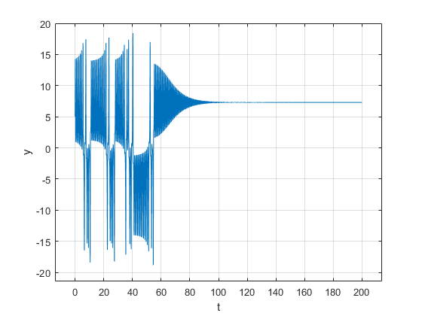
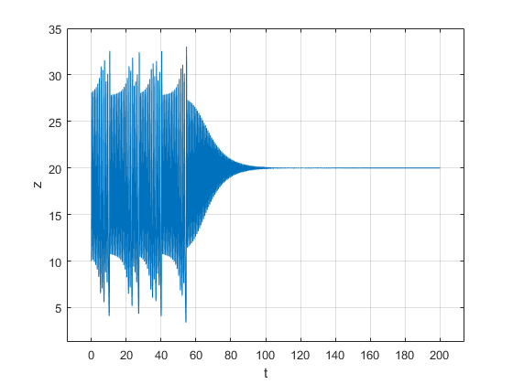
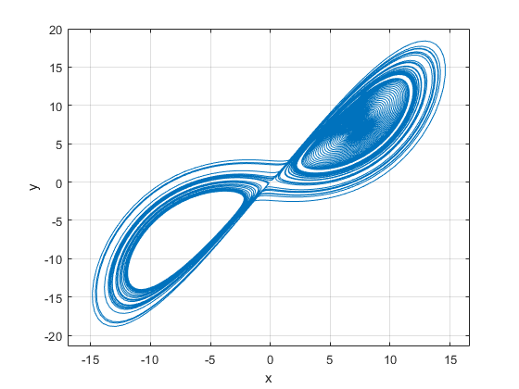
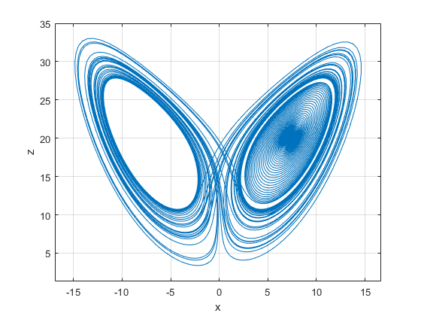
Published with MATLAB® R2021a

